FINAL DOCUMENT

International Medical Device Regulators Forum

Title: Clinical Investigation

Authoring Group: Medical Device Clinical Evaluation Working Group

Date: 10 October 2019

Elena M. Astapenko, IMDRF Chair

This document was produced by the International Medical Device Regulators Forum. There are no restrictions on the reproduction or use of this document; however, incorporation of this document, in part or in whole, into another document, or its translation into languages other than English, does not convey or represent an endorsement of any kind by the International Medical Device Regulators Forum.

Copyright © 2019 by the International Medical Device Regulators Forum

CONTENTS

Preface
1.0 Introduction 4
2.0 Scope 4
3.0 References 5
4.0 Definitions 5
5.0 General Principles When Considering the Need for a Clinical Investigation 7
6.0 General Principles of Clinical Investigation Design 9
7.0 Ethical Considerations for Clinical Investigations 11

Preface
The document herein was produced by the International Medical Device Regulators Forum (IMDRF), a voluntary group of medical device regulators from around the world. The document has been subject to consultation throughout its development.

There are no restrictions on the reproduction, distribution or use of this document; however, incorporation of this document, in part or in whole, into any other document, or its translation into languages other than English, does not convey or represent an endorsement of any kind by the International Medical Device Regulators Forum.

1.0 Introduction
This document supersedes an earlier version produced under the Global Harmonization Task Force (GHTF) with the same title in February, 2010 (GHTF/SG5/N3:2010).

What is a clinical investigation?

A clinical investigation is defined as any systematic investigation or study in or on one or more human subjects, undertaken to assess the safety, clinical performance and/or effectiveness of a medical device.

The undertaking of a clinical investigation is a scientific process that represents one method of generating clinical data.

What is the objective of a clinical investigation?

The objective of a clinical investigation is to assess the safety, clinical performance and/or effectiveness of a medical device for a particular indication or intended use.

How is a clinical investigation conducted?

ISO 14155: 2011 Clinical Investigation of Medical Devices for Human Subjects — Good clinical practice details the requirements for the conduct of clinical investigations. Clinical investigations must take into account scientific principles underlying the collection of clinical data along with accepted ethical standards surrounding the use of human subjects.

2.0 Scope
The primary purpose of this document is to provide guidance in relation to:

- when a clinical investigation should be undertaken for a medical device to demonstrate compliance with the relevant Essential Principles (see IMDRF/GRRP WG/N47 FINAL:2018 “Essential Principles of Safety and Performance of Medical Devices and IVD Medical Devices”); and
- the general principles of clinical investigation involving medical devices.

Given the wide diversity of medical devices and their associated risks, this document is not intended to provide comprehensive guidance for clinical investigations of specific medical devices.

The guidance contained within this document is intended to apply to medical devices other than IVDDs. Additionally, this document was drafted primarily to address the use of Clinical Investigations to support a marketing authorization application. Some aspects of this document may apply to studies conducted following commercial release of a medical device. The GHTF /SG5/N4:2010 – Post-Market Clinical Follow-Up Studies document specifically addresses post-market clinical follow-up studies.

3.0 References
IMDRF/GHTF final documents

GHTF SG1/N011:2008 Summary Technical Documentation for Demonstrating Conformity to the Essential Principles of Safety and Performance of Medical Devices (STED)

GHTF SG1/N029:2005 Information Document Concerning the Definition of the Term “Medical Device”

IMDRF GRRP WG/N47 FINAL: 2018 Essential Principles of Safety and Performance of Medical Devices and IVD Medical Devices

GHTF SG1/ N78:2012 Principles of Conformity Assessment for Medical Devices

IMDRF/GRRP WG/N52 FINAL: 2019 Principles of Labeling for Medical Devices and IVD Medical Devices document when released

IMDRF MDCE WG/N55FINAL:2019 Clinical Evidence – Key definitions and Concepts

IMDRF MDCE WG/N56FINAL:2019 Clinical Evaluation

International standards

ISO 14155:2011 Clinical investigation of medical devices for human subjects — Good clinical practice

ISO 14971:2007 Medical devices -Application of risk management to medical devices

Other References

World Medical Association – Declaration of Helsinki - Ethical principles for medical research involving human subjects

4.0 Definitions
Adverse Event: Any untoward medical occurrence in patients/subjects, users or other persons, whether or not related to the investigational device, that occurred in the course of the investigation. (Note: For users or other persons, this definition is restricted to events related to investigational medical devices.)

Clinical Data: Safety, clinical performance, and/or effectiveness information that is generated from the clinical use of a medical device.

Clinical Evaluation: A set of ongoing activities that use scientifically sound methods for the assessment and analysis of clinical data to verify the safety, clinical performance, and/or effectiveness of the medical device when used as intended by the manufacturer.

Clinical Evidence: The clinical data and its clinical evaluation pertaining to a medical device.

Clinical Investigation: Any systematic investigation or study in or on one or more human subjects, undertaken to assess the safety, clinical performance, and/or effectiveness of a medical device.

Clinical Investigation Plan: Document that states the rationale, objectives, design and pre-specified analysis, methodology, monitoring, conduct and record-keeping of the clinical investigation.

Clinical Performance: The ability of a medical device to achieve its intended clinical purpose as claimed by the manufacturer.

Conformity Assessment: The systematic examination of evidence generated and procedures undertaken by the manufacturer, under requirements established by the Regulatory Authority, to determine that a medical device is safe and performs as intended by the manufacturer and, therefore, conforms to the Essential Principles.

Effectiveness: The ability of a medical device to achieve clinically meaningful outcome(s) in its intended use as claimed by the manufacturer.
Endpoint: An indicator used for providing the evidence for safety, clinical performance, and/or effectiveness in a clinical investigation (ISO 14155:2011, modified).

Multi-Regional Clinical Investigation: A clinical investigation conducted in more than one region under a single protocol.

Region: A geographical region, country or regulatory region.

Regulatory Region: A region comprised of jurisdictions for which common sets of regulatory requirements apply.

Residual Risk: Risk remaining after risk control measures have been taken (ISO 14971:2007).

Risk Management: Systematic application of management policies, procedures and practices to the tasks of analysing, evaluating, controlling and monitoring risk (ISO 14971).
Safety: Acceptability of risks as weighed against benefits, when using the medical device according to the manufacturer’s labelling.

5.0 General Principles When Considering the Need for a Clinical Investigation

When should a clinical investigation be undertaken?

Clinical investigations are necessary to provide data not available through other sources (such as literature or nonclinical testing) required to demonstrate compliance with the relevant Essential Principles (including safety, clinical performance and acceptability of benefit/risk associated with its use). When a clinical investigation is conducted, the data obtained is used in the clinical evaluation process and is part of the clinical evidence for the medical device (see IMDRF/MDCE WG/N56FINAL:2019– “Clinical Evaluation”).

When considering the need for a clinical investigation, one should consider whether there are new questions of safety, clinical performance and/or effectiveness for the particular medical device and intended use that need to be addressed in a clinical investigation. Generally, such questions are more likely to be generated for high risk and/or novel medical devices.
For long established technologies, the clinical investigation data that might be required for novel technologies may not be necessary. The available clinical data in the form of, for example, published literature, reports of clinical experience, post-market reports and adverse event data may, in principle, be adequate to establish the safety, clinical performance, and/or effectiveness of the medical device, provided that new risks have not been identified, and that the intended use(s)/purpose(s) has/have not changed.
What are the key considerations in clarifying the need for clinical investigations?

- Identifying relevant clinical Essential Principles (for example, specifics of safety, clinical performance, acceptability of benefit/risk) for the medical device and its intended use/purpose(s) (see IMDRF/GRRP WG/N47 FINAL:2018 Essential Principles of Safety and Performance of Medical Devices and IVD Medical Device);

- Performing risk management (ISO 14971:2007) activities such as a risk analysis will help in identifying the clinical data necessary to address residual risks and aspects of clinical performance not completely resolved by available information (e.g. design solutions, nonclinical and material/technical evaluation, conformity with relevant standards, labelling).

Risk control measures include inherent safety by design, protective measures in the medical device itself or in the manufacturing process, and information for safety. The decision to use a medical device in the context of a clinical procedure requires the residual risk to be balanced against the anticipated benefits of the procedure. A clinical investigation may be required to further elucidate the benefit/risk in a defined patient population;

- Conducting a proper clinical evaluation will demonstrate which clinical data are necessary, and can be adequately contributed to by sources such as literature searching, prior clinical investigations (including clinical data generated in other jurisdictions), clinical experience, or clinical data available from comparable devices, and which clinical data should be generated from clinical investigation(s) when data are unavailable or insufficient to demonstrate conformity to the Essential Principles. Available clinical data from comparable devices should be carefully examined for comparability and adequacy (see IMDRF/MDCE WG/N56 FINAL:2019 Clinical Evaluation).

Key considerations for clarifying the need for clinical investigations are illustrated by the flowchart in Figure 1.

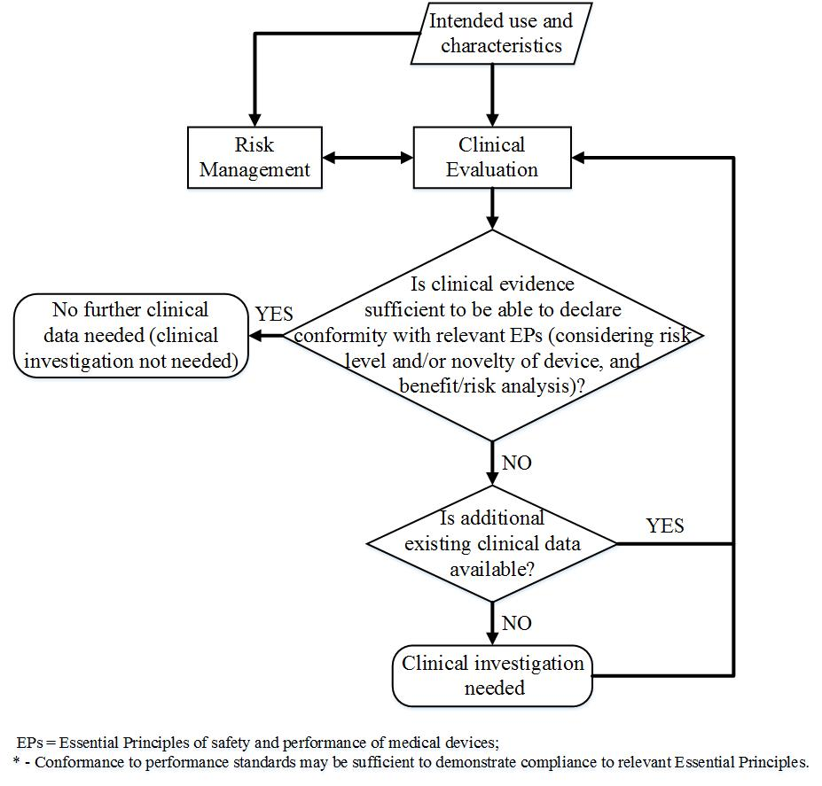
Figure 1 Key considerations for clarifying the need for clinical investigations.

Where uncertainty exists as to whether current data are sufficient to demonstrate conformity with the Essential Principles, discussion with the relevant regulatory authorities or conformity assessment bodies may be appropriate.

Note: This exercise is applicable for the introduction of a new medical device as well as for planned changes of a device, its intended use and/or claims.

6.0 General Principles of Clinical Investigation Design

Any clinical investigation must:

- be based on the results of the clinical evaluation process;
- follow a proper risk management procedure to avoid undue risks;
- be compliant with all relevant legal and regulatory requirements;
- be appropriately planned, conducted, analysed and reported;
- follow appropriate ethical principles (see Section 7).

The design of the clinical investigation, including the study objectives and statistical considerations, should provide the clinical data necessary to address the residual risks, including aspects of clinical performance. Some factors that may influence the extent of data requirements include, but are not limited to, the following:
- type of medical device and/or regulatory classification;
- novel technology/relevant previous experience;
- clinical application/indications;
- nature of exposure to the product (e.g. surface contact, implantation, ingestion)
- risks inherent in the use of the product (e.g. risk associated with the procedure)
- performance claims made in the medical device labeling (including instructions for use) and/or promotional materials
- component materials or substances
- disease process (including severity) and patient population being treated
- demographic, geographic and cultural considerations (e.g. age, ethnicity, gender)
- potential impact of device failure
- period of exposure to the medical device
- expected lifetime of the medical device
- availability of alternative treatments and current standard of care
- ethical considerations
Considerations for Medical Device Study Protocols
Factors needing consideration in study protocols include:
- clear statement of objectives
- minimization of risk to subjects and those involved with the conduct of the investigation
- adverse event definitions and reporting
- study endpoints
- appropriate subject population(s)
- minimization of bias (e.g. randomization, blinding/masking, concealment of allocation)
- identification of confounding factors (e.g. concurrent therapies, co-morbidities)
- choice of appropriate controls (e.g. active control, sham, historical)
- design configuration (e.g. parallel, crossover, cohort study, single arm)
- type of comparison (e.g. superiority, non-inferiority, equivalence)
- follow-up duration and monitoring
In designing the study, statistical considerations should be prospectively specified and be based on sound scientific principles and methodology. Development of a statistical plan should include consideration of the following:
  - clinically relevant endpoints
  - analysis population
  - statistical significance levels, power
  - sample size calculation and justification
  - analysis methodology
  - management of potential confounding factors
  - procedures for multiplicity control and adjustment of error probabilities
  - procedures for handling of missing, unused or spurious data, including drop-outs
  - procedures for handling deviations from the original statistical analysis plan
and, as applicable:
  - accounting for learning curve issues
  - specification of interim analyses
  - specification of subgroup analyses
The design should ensure that the statistical evaluation derived from the investigation reflects a meaningful, clinically significant outcome.
Multi-regional clinical investigation designs may be considered to facilitate more efficient medical device development, thus providing earlier access to new medical devices worldwide. For multi-regional clinical investigation designs, the potential differences between two or more regions that might affect study results should be carefully considered.
Discussion with the relevant regulatory authorities or conformity assessment bodies may be appropriate when there is uncertainty as to whether the proposed clinical investigational plan is sufficient.
Conduct of Clinical Investigations
A properly conducted clinical investigation, including compliance to the clinical investigation plan and local laws and regulations, ensures the protection of human subjects, the integrity of the data and that the data obtained is acceptable for the purpose of demonstrating conformity to the Essential Principles. ISO 14155 outlines good clinical practice for clinical investigations of medical devices.
Final Study Report
The outcome of a clinical investigation should be documented in a final study report. This then forms part of the clinical data that is included in the clinical evaluation process and ultimately becomes integrated into the clinical evaluation report (see IMDRF/MDCE WG/N56FINAL:2019 Clinical Evaluation) for the purposes of conformity assessment.

7.0 Ethical Considerations for Clinical Investigations

As a general principle, “the rights, safety and wellbeing of clinical investigation subjects shall be protected consistent with the ethical principles laid down in the Declaration of Helsinki” and the applicable regulatory requirements or other relevant standards (ISO 14155:2011).

It is ethically important in deciding to conduct a clinical investigation that it should generate new data and answer specific safety, clinical performance, and/or effectiveness questions that remain unanswered by the current body of knowledge. The desire to protect human subjects from unnecessary or inappropriate experimentation must be balanced with the need to protect public health through the use of clinical investigations where they are indicated. In all cases, however, care must be taken to ensure that the necessary data are obtained through a scientific and ethical investigational process that does not expose subjects to undue risks or discomfort. The rights, safety and well-being of subjects are paramount, and appropriate trial design and conduct is essential to generate meaningful data.

